Lloyd, John
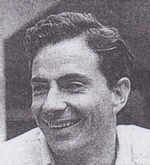
BSc Forestry ANU in 1987. Assistant Divisional Forest Officer with CALM at Harvey in 1988. Transferred to Manjimup 1988. District Manager at Mundaring in 2000. Left CALM before 2001.

